**Maces and Talons**

Final Report for CS39440 Major Project

*Author*: Callum Gwynedd Hay Hutchinson ([cgh2@aber.ac.uk](mailto:cgh2@aber.ac.uk))

*Supervisor*: Dr Bernie Tiddeman (bpt@aber.ac.uk)

16th April 2018

Version 1.0 (Draft)

This report is submitted as partial fulfilment of a BSc degree in  
Computer Science including Integrated Industrial and Professional Training (G401)

Department of Computer Science

Aberystwyth University

Aberystwyth

Ceredigion

SY23 3DB

Wales, UK

**Declaration of originality**

I confirm that:

* This submission is my own work, except where clearly indicated.
* I understand that there are severe penalties for Unacceptable Academic Practice, which can lead to loss of marks or even the withholding of a degree.
* I have read the regulations on Unacceptable Academic Practice from the University’s Academic Quality and Records Office (AQRO) and the relevant sections of the current Student Handbook of the Department of Computer Science.
* In submitting this work I understand and agree to abide by the University’s regulations governing these issues.

Name …………………………………………

Date ……………………………………………

**Consent to share this work**

By including my name below, I hereby agree to this dissertation being made available to other students and academic staff of the Aberystwyth Computer Science Department.

Name …………………………………………

Date ……………………………………………

**Acknowledgements**

I am grateful to…

I’d like to thank…

**Abstract**

This aim of this project was to produce a video game representation of the medieval Scandinavian board game Hnefatafl, providing single device and online multiplayer support.

**Contents**

1. Background, Analysis & Process 3546 6

1.1. Background 567 6

1.1.1. Similar Systems 953 8

1.1.2. Development Research 762 12

1.2. Analysis 463 14

1.2.1. Deliverables 511 15

1.3. Process 290 16

2. Design 17

2.1. Overall Architecture 17

2.2. Detailed Design 17

2.2.1. Even More Detail 17

2.3. User Interface Design 17

2.4. Other Relevant Sections 17

3. Implementation 18

4. Testing 19

4.1. Overall Approach to Testing 19

4.2. Automated Testing 19

4.2.1. Unit Tests 19

4.2.2. User Interface Testing 19

4.2.3. Stress Testing 19

4.2.4. Other Types of Testing 19

4.3. Integration Testing 19

4.4. User Testing 19

5. Critical Evaluation 20

5.1. Research 20

5.2. Requirements 20

5.3. Design Decisions 20

5.4. Tools 151 20

5.5. Future Work 20

5.5.1. Authoritative Server 20

5.5.2. Google Play integration 20

5.5.3. Online Lobby 20

5.5.4. 2D View 20

6. Appendices 21

A. Third-Party Code and Libraries 21

B. Ethics Submission 22

C. Code Samples 22

Annotated Bibliography 23

# Background, Analysis & Process

## Background 567

The Project aims to create a video game based on the Scandinavian medieval board game ‘Hnefatafl’, this game would feature a single device two player hot seat mode and an online multiplayer mode.

Having previously developed two Android applications and several years of experience developing in Unity 3D, this project idea was interesting to me because I could use skills that I had learnt at University and skills developed in my spare time to produce my best game so far.

‘Hnefatafl’ is a variant of the larger game ‘Tafl’, Tafl is a board game in which two forces much like chess compete against each other to win, unlike chess the two sides are uneven and have different win conditions. As the board game moved around northern Europe different rulesets were developed and layouts to the board and pieces [5], ‘Hnefatafl’ which is the Scandinavian variety uses a board which is 11 squares by 11 squares (11x11) or less commonly 13x13, there are other known types such as ‘Ard-Ri’ and ‘Tawlbyund’ which use 7x7 and 11x11 respectively.

The two different board sizes for Hnefatafl also presents two different configurations for the pieces as shown in Fig 1, while the outside ‘Barbarian’ pieces remains the same the Vikings in the centre have a slightly different formation.

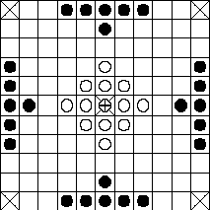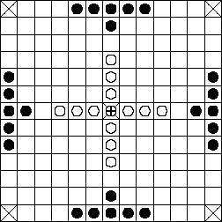

Figure ,[5] The two sizes of Hnefatafl board with the pieces arranged accordingly.

Due to time restrictions the Project just focuses on the more commonly used board size 11x11 and the corresponding piece layout, however there is the option to add the other size if time permits.

The rules of Hnefatafl are a lot simpler than those of chess, all pieces move in the same manner, in straight lines horizontally and vertically as far as they want until hitting an obstruction. This is much the same as a rook in chess except that you do not take a piece by going on to its space, pieces in Hnefatafl cannot pass through or go on to space occupied by another space, this allows for strategies that rely on blocking the opposing team off. To take a piece it must have two opposing pieces on two opposite sides, therefore creating a line of three, the taken piece is removed from the game. The one unique piece is the ‘King’ this is placed in the centre of the board and is surrounded by the ‘Knights’ or in the case of ‘Hnefatafl’ the ‘Vikings’, to take/capture the King it must be surrounded on all four sides by opposing pieces or edges of the game board. Fig 2 shows the different cases when the King could be taken, the difficulty of taking the King is made easier by the uneven numbers, the ‘Barbarians’ have almost double the number of pieces at 24 versus the ‘Viking’s’ 13.

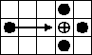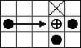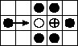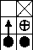

Figure , [5] All cases in which the King would be taken.

The objectives of both teams are different, the ‘Barbarian’s’ sole goal is to capture the King, theoretically this also could lead to them capturing all of the other Viking pieces but this is not necessary for them to win. The ‘Vikings’ must get their King to one of the 4 corners of the board to win, or capture all of the opposing ‘Barbarians’ but this is highly unlikely due to the imbalance in the two sides, this outcome would only happen if the person controlling the ‘Barbarians’ is very inexperienced.

### Similar Systems 953

There are several Android applications that are published on the ‘Google Play Store’ and emulate ‘Hnefatafl’, they provide features that the project aims to produce and this allows me to analyse them and see what works well and if anything can be improved. Due to the nature of the game, many of the features are similar in each version and most of these will be included but I will evaluate the importance of their completion in terms of development time.

#### Hnefatafl [2]

The first version that I looked at contains a mixture of features some that will not be included in the project, this version only contains offline modes, a ‘hot-seat’ mode as the project will contain and an offline AI mode against a varying difficulty of opponents.

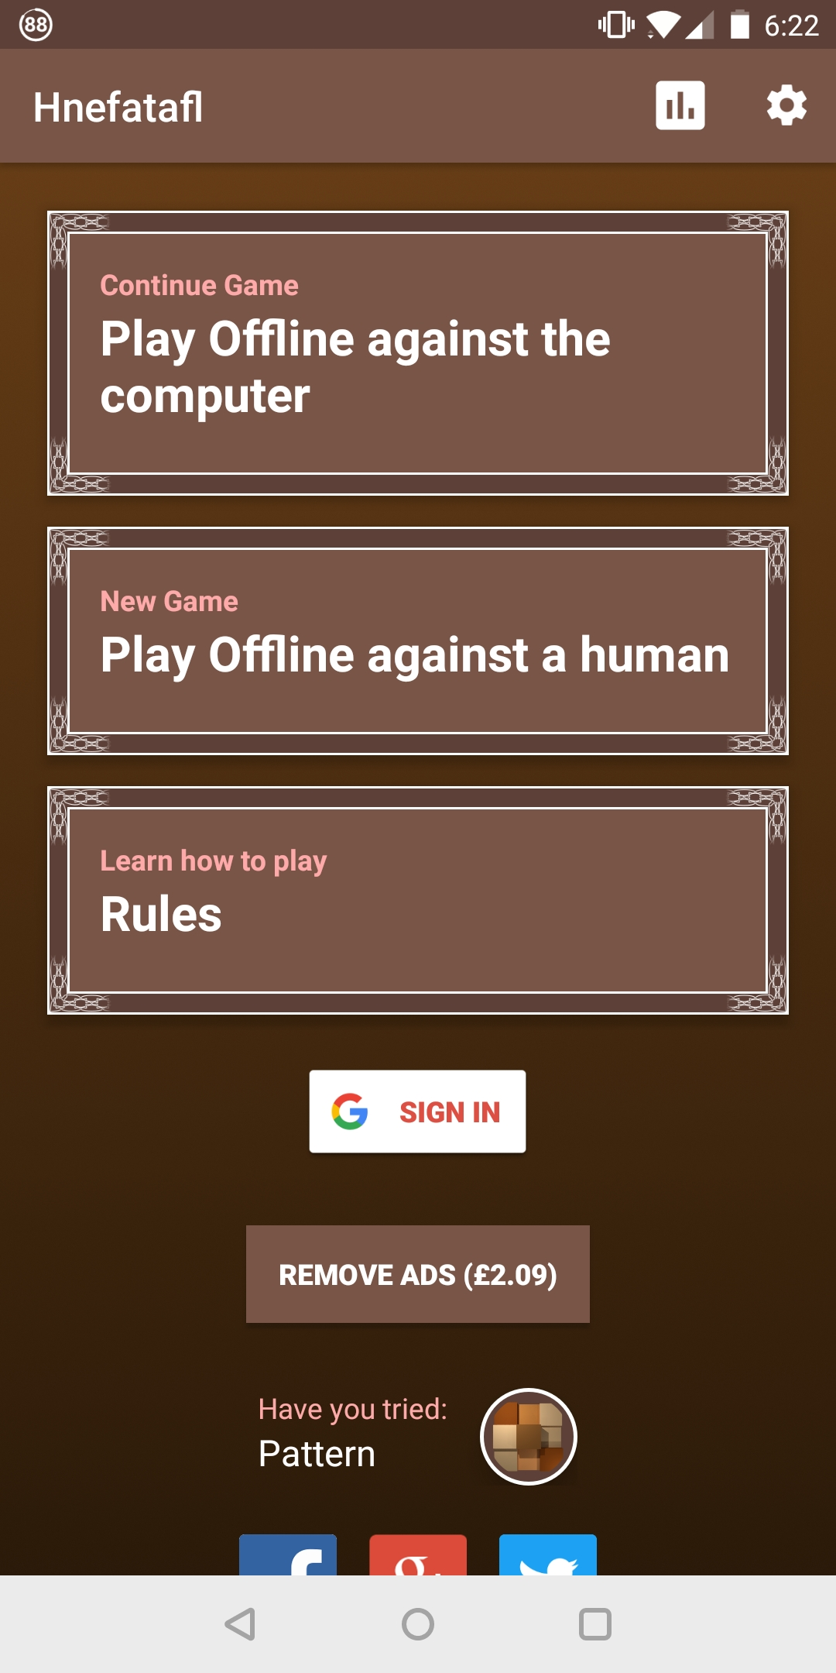

Figure

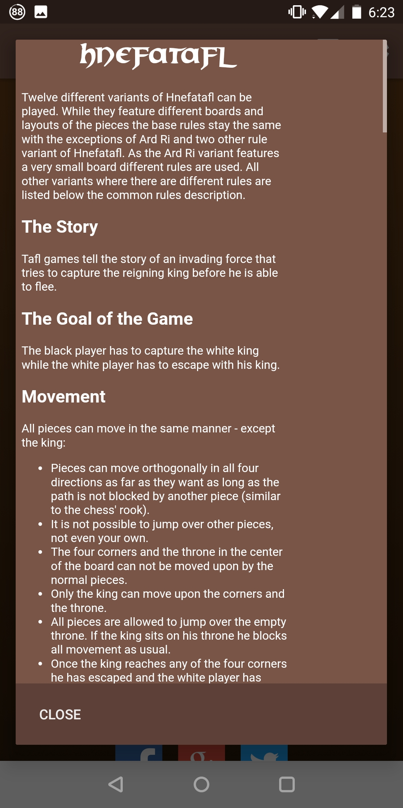

Figure

Figure 3 shows visually the user interface is minimal and while not overly attractive it does what it needs to do providing clear options to the user, with my limited art skills this should be something I aim for in the Project.

Figure 4 is a useful feature that shows the rules of the game to the player, since Hnefatafl and other Tafl games are quite different to other games it is hard to show this visually, this may be something that I can improve on in the Project.

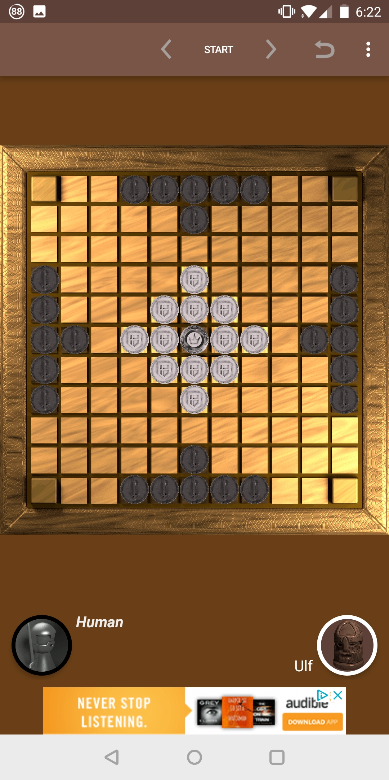

Figure

Much like the user interface this game features a simplistic board design, this can be seen in Figure 5. It does allow the user to select assorted styles of playing pieces, and this game also allows the selection of different board sizes and layouts of pieces

While the project will focus solely on the Hnefatafl version of the game, the simplistic user interface and game view could be of inspiration.

#### Tafl [3]

This game offers offline play against the computer and online multiplayer, it is unusual that is doesn’t offer offline multiplayer as that is the easiest method to implement. Much like the previously analysed game [2] this offers different layouts for the boards as seen in Figure 6. With these different board layouts there should be accompanying rules changes, but after testing out the board layout for Hnefatafl there is slight inconstancies with the other two games that I tried. These changes in the rules could be attributed to personal interpretation by the developer as the game itself has many different variations and origins. The project will stick to the most commonly established rules as this will be easier for inexperienced users to pick up and returning users of the system to know the rules straight away.

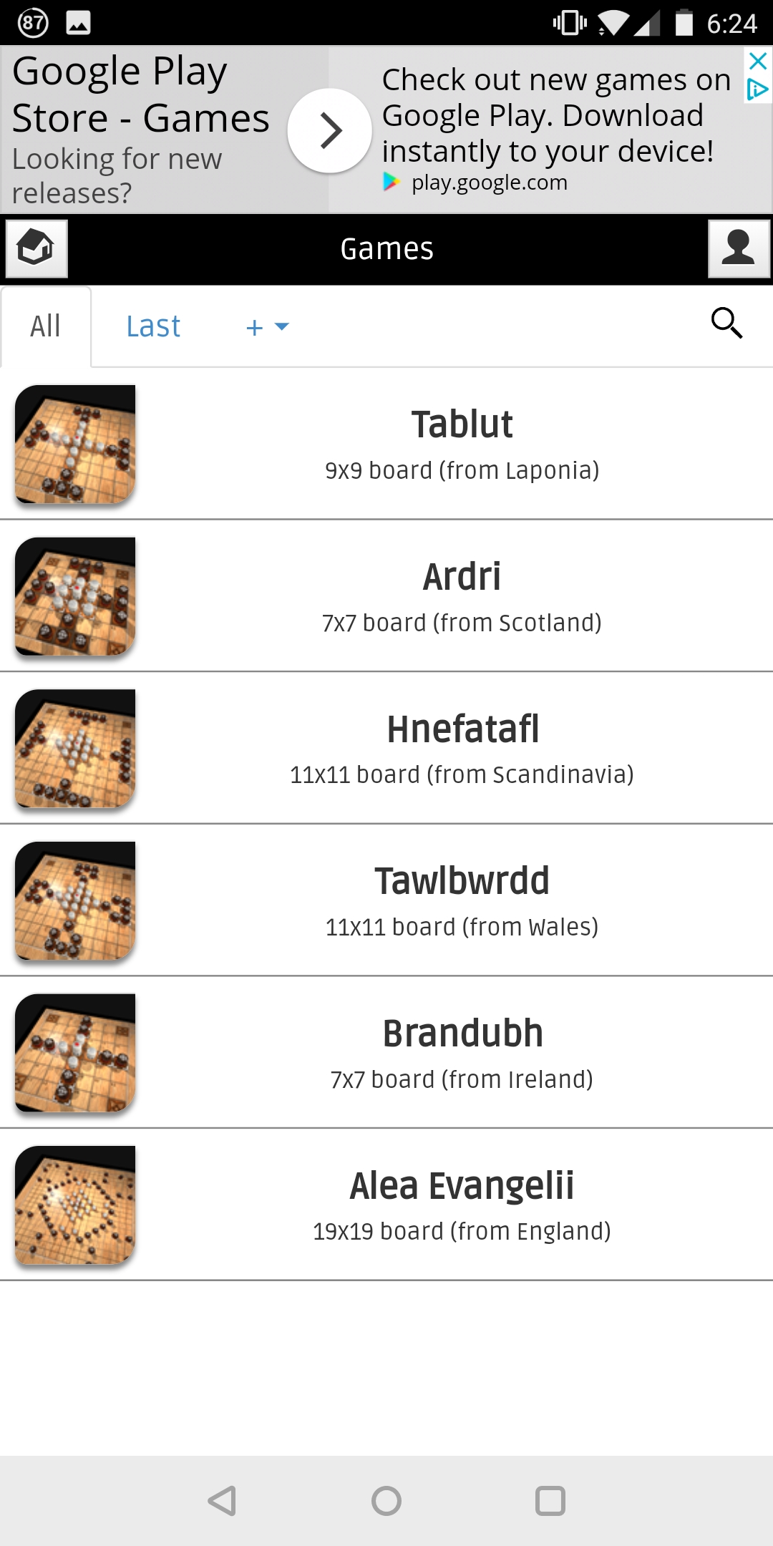

Figure

The user interface when starting a game (Figure 7) is a bit confusing, and does not easily show how to setup multiplayer games. The buttons for game setup should be obviously distinguishable from the other information buttons, in this case they are coloured different colours to the grey icons for other information, but their size could have been increased to improve their prominence on the screen. The image showing the game board is slightly unnecessary as we have previously chosen which board we want to use and could free up space for clearer buttons.

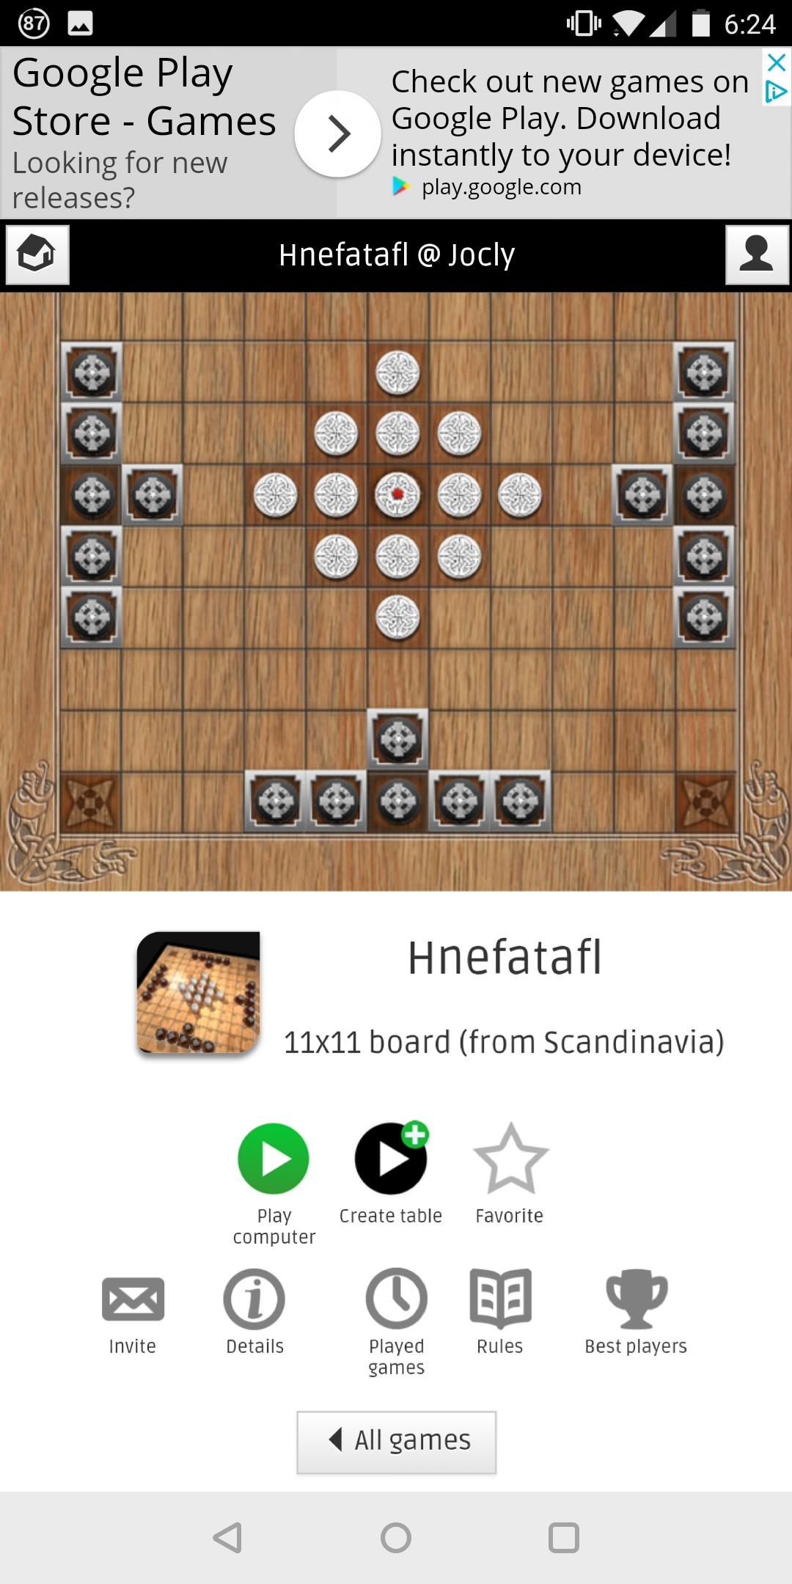

Figure

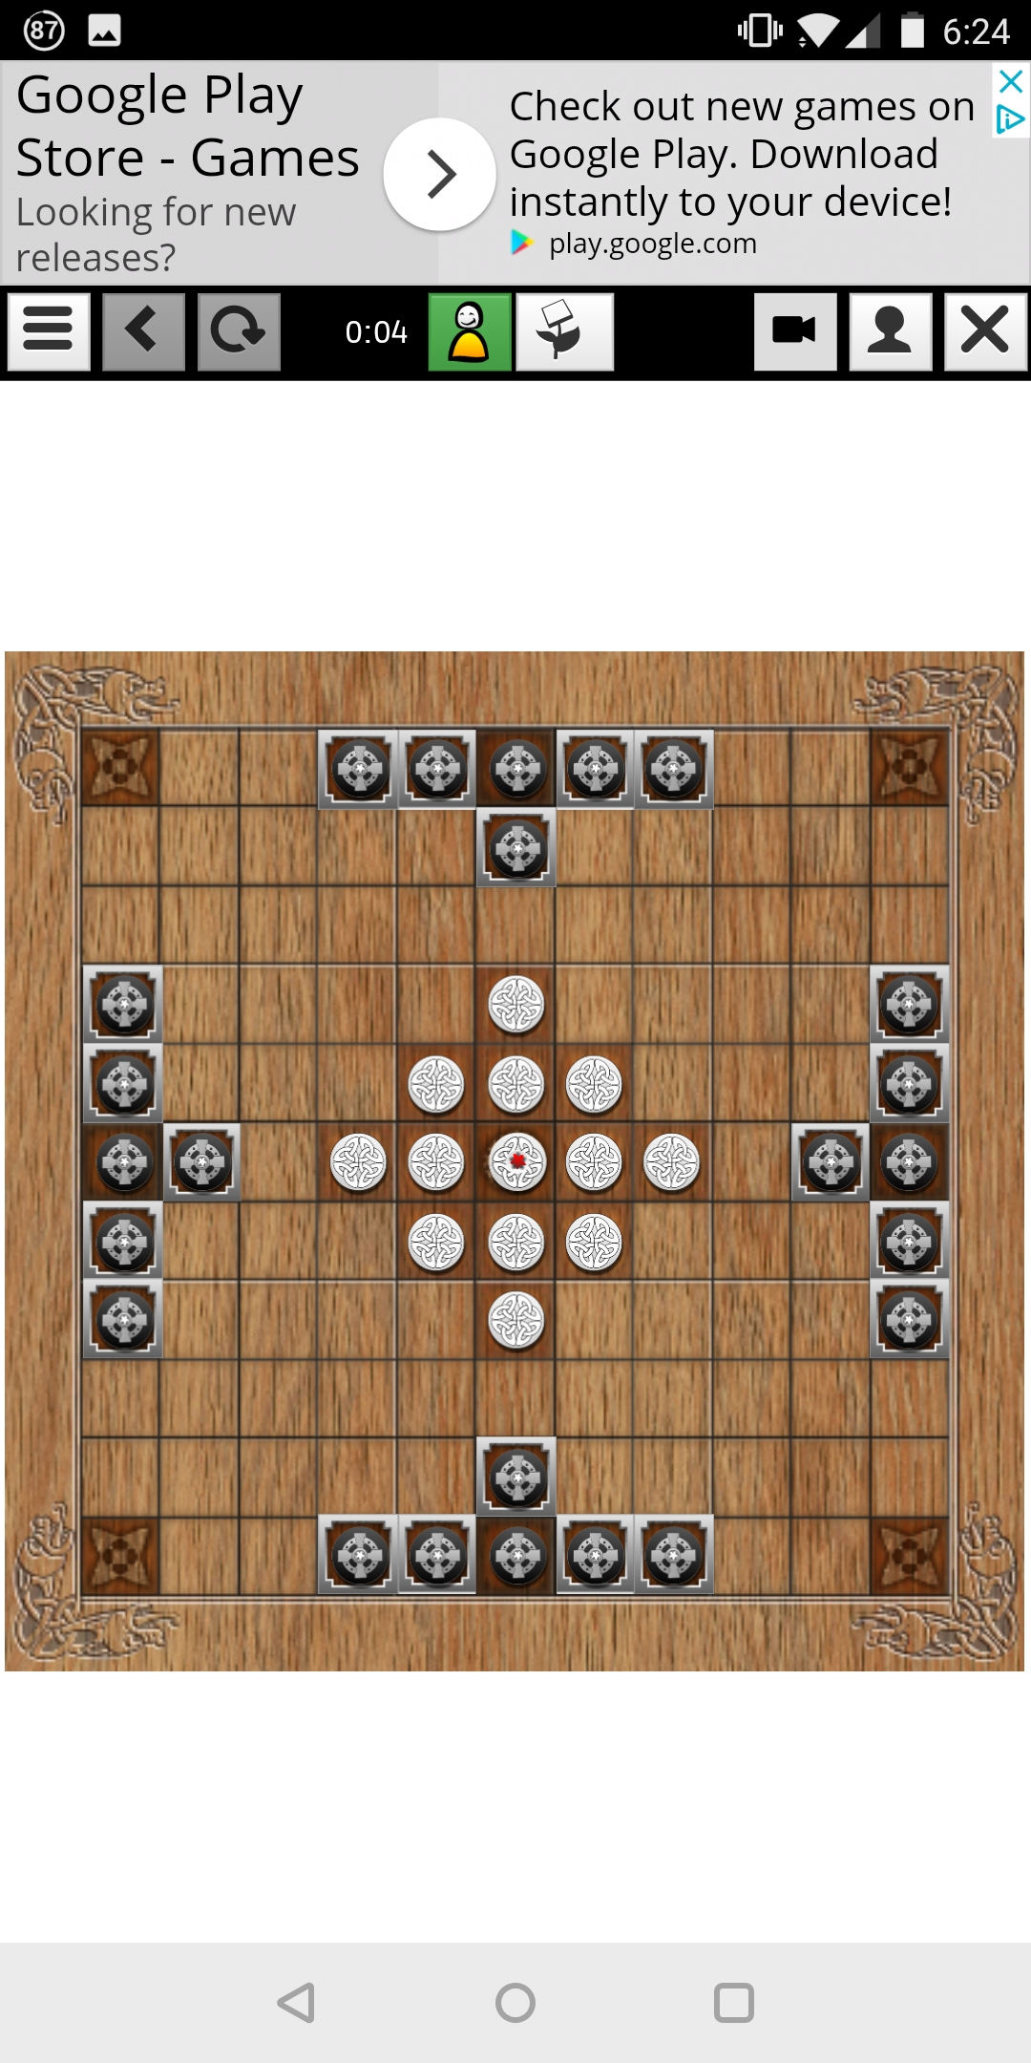

Figure

The game view (Figure 8) has the most simplistic interface compared to all the comparisons and represents the game in a classic top down 2D view. It doesn’t show any additional information including which team is starting, this can make it confusing if you are playing the computer and you have been selected to go first (which during my testing happened every time).

#### Hnefatafl [4]

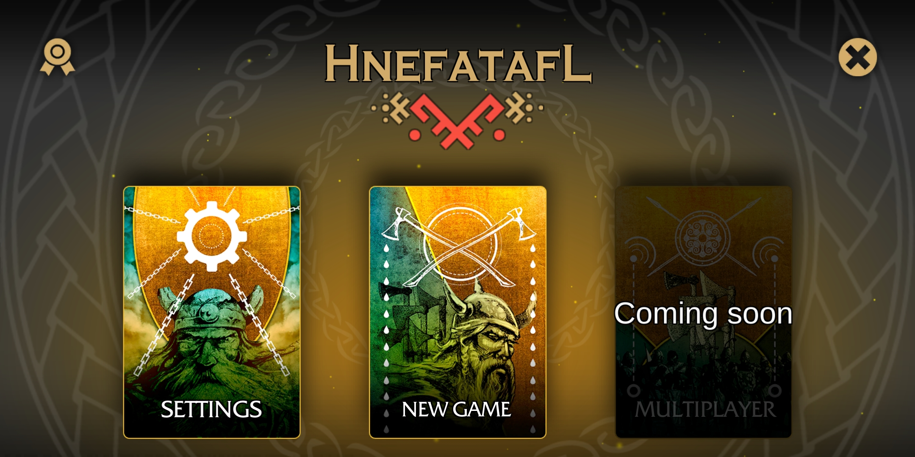

Figure

This game was by far the most graphically appealing game and a lot of effort had been put into art assets, the main menu (Figure 9) is very clean and directs the user to the main aspects of the game. Interestingly the game was made with the same game engine which the project is going to be made in which shows the graphics and polish that it is capable of.

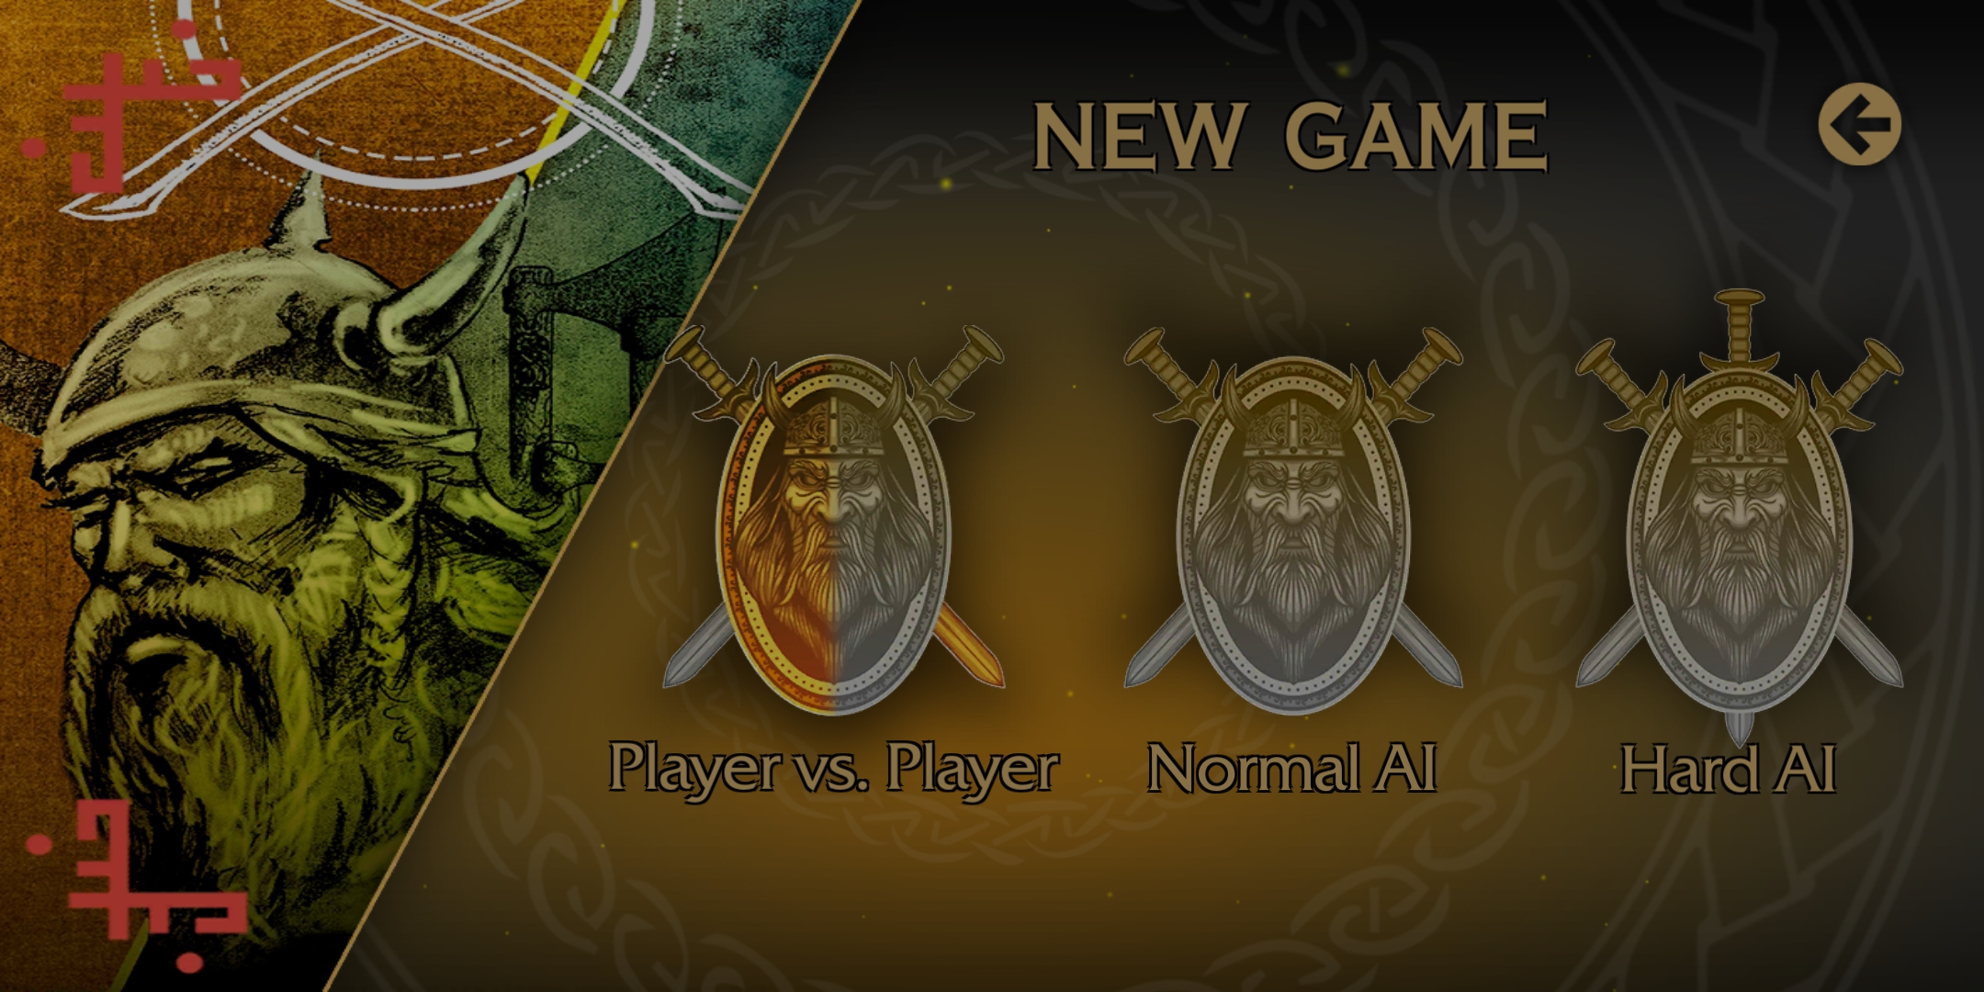

Figure

Several game modes exist in this game (Figure 10), all of them are offline currently with a grey out box for multiplayer shown in Figure 9. There exist two different difficulty levels of AI opponent which provides a small choice in opponent variety compared to [2] which had 10+ difficulty levels. The project will not focus on an AI opponent and focus on multiplayer so there is not much to learn here.

The game view is the most unique of the three games, changing styles from a 2D top down view to a 3D view with modelled game board and pieces while also implementing lighting and shaders. During gameplay on this version I noticed several gameplay choices which may have been intentional but I believe to be bugs, such as when a piece was selected at the beginning of your turn you could not then select another piece and must move the piece selected. This shows as a first-time player to the game that even small bugs can be deterring to a player and good first impressions are paramount.

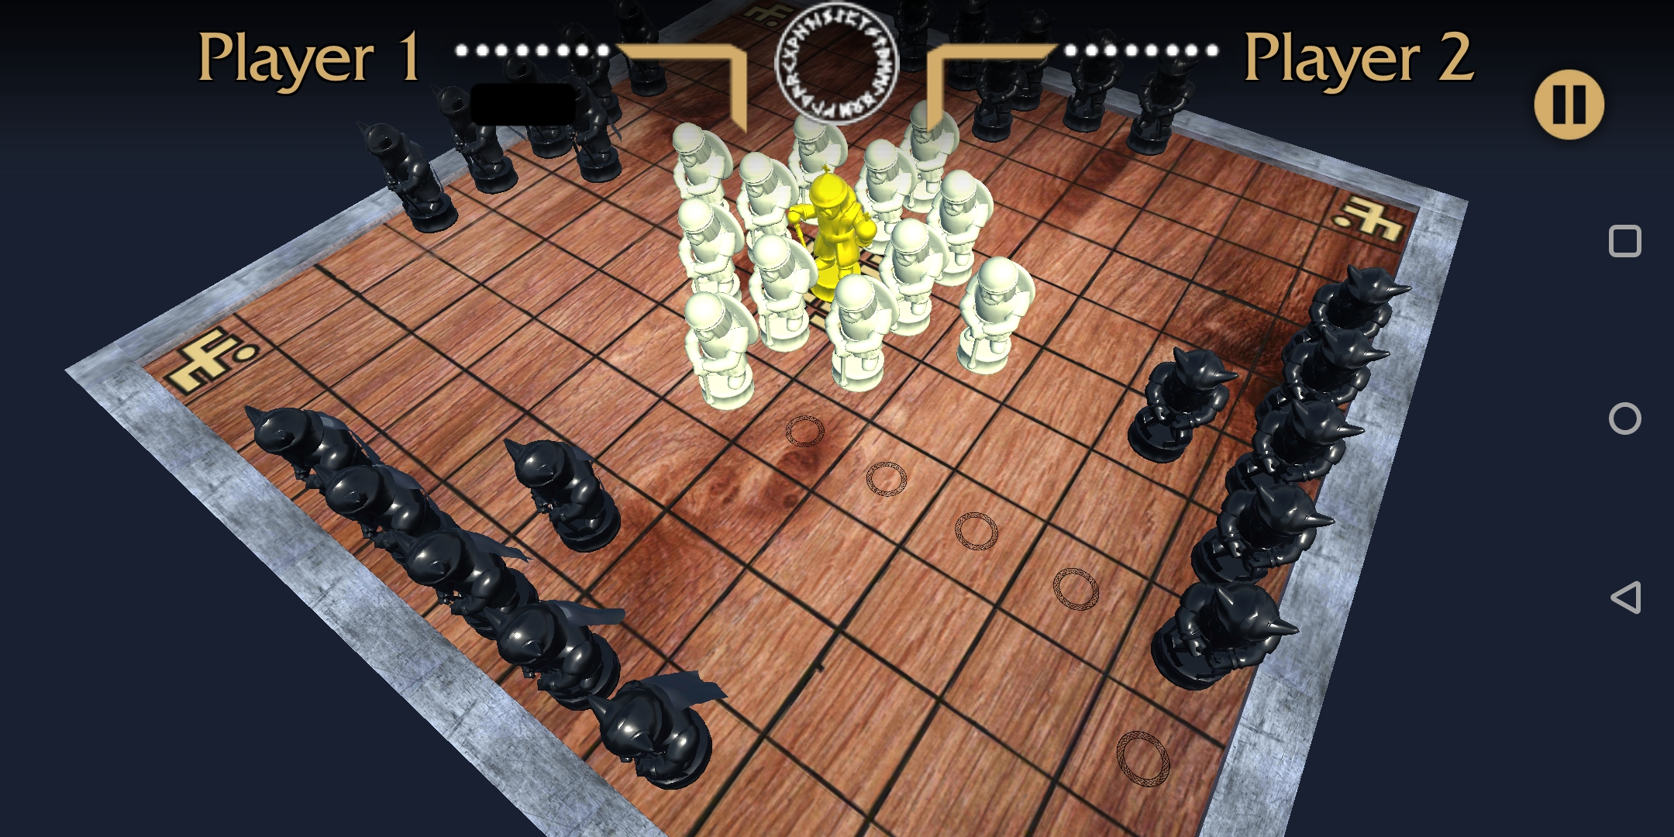

Figure

#### Conclusion of similar systems

None of the existing interpretations that I have looked at contain the exact mix of features which the project aims to bring, but it has given me the chance to study how each one implemented their version of the features that will be included. Online and offline multiplayer will play a big part, unfortunately there is only one game with functioning multiplayer but all of them features offline multiplayer for me to look at. Graphically the style that stood out the most was the one used the least, and makes a static board game feel the most interactive.

### Development Research 762

For the project there are several different technology choices that must be made as they will be the key tools used during development, changing any of these during the project could possibly require starting the entire project again.

#### Unity

Personally, I have developed basic Android applications using the Unity game engine so this was the immediate choice when deciding how to implement the project. Having previous developed in Java this was a possibility but even when using a framework such as the one provided by Android Studio the amount of work to develop certain features for example, a 3D environment is already provided and objects can be placed with in the world, as well as a built in shader and lighting system.

The choice to use Unity, allows easy exporting of the project to a wide variety of platforms. Java would also allow the ability to run on many different systems, but they require the JRE (Java Runtime Environment) to be install, Unity provides native builds for each platform that it is exported to, this means they can run it without the need to install extra software.

#### C# or Java

Developing the Multiplayer server will be one of the most technically challenging parts of the project, the language to develop it in then is very important and must be chosen carefully. The two languages that are in consideration are C# and Java, syntactically these languages are practically identical and some code can literally be copied from one to another, their main difference is in how they are run.

Java being an interpreted language requires the JRE (Java Runtime Environment) to be installed on target machines, there is some associated performance overhead because the code must be executed and converted to machine code at runtime. C# on the other hand is built by a compiler into an executable binary, this typically can only be run on a Windows but due to the language being developed using the Common Language Interface (CLI) specification [9] it can be run on several other systems.

The two languages are very similar and besides the target platforms there are no other major differences between the two, for this project it will be easier to develop in C# as the scripts used in the Unity Engine are in C# and code can be shared across applications to speed up development.

#### TCP vs UDP

When implementing an online multiplayer system there are different networking protocols to consider, TCP (Transmission Control Protocol) and UDP (User Datagram Protocol). They are both different methods of transferring data packets across a network, each with contrasting features to the other.

TCP is considered to be the slower but more reliable protocol [11], it achieves this by sending each the packets with reference to the order they were sent it, e.g. packet 1 has a reference of one, packet 2 has a reference of two, etc. This allows the receiving machine to know how to order the packets and if any have been lost, if a 2 arrives before 1, it will wait until it has 1 and then process them in order. This is where the speed can decrease, if many packets are arriving out of order then it will take time to wait for the correct ones to arrive. Even worse can be if a packet does not make it at all, then the client must send a request for the missing packet to be resent which creates more overhead.

Conversely UDP does not have any built-in ordering and unlike TCP all of the packets do not follow the same route to the target machine either. If a packet finds a faster route than the packets that left before it, then it could arrive before they do. This is when errors can occur with out of order packets, unless a method of ordering the packets has been implemented then they will just be processed as they arrive, even if they are early.

UDP is more suited to a real-time application where you need the data continuously sending across the network and can afford some data loss with the trade-off of speed. TCP even with its drawback of increased overhead when needing to request packets to be resent, it can guarantee that the packets will arrive and that none of the data is lost. The project will be implementing a turn based system for the game, therefore a real-time solution is not needed. The user will never noticeably experience the difference between TCP or UDP so the most reliable protocol will have to be used.

## Analysis 463

Using the background research, the project could take rough shape and provide some criteria to follow and what would be produced at the end of the project.

To allow more time to develop the key defining features of the game client, the Unity engine was decided to be a better choice over making the game from scratch in Java or even using the Android Studio to provide some support for Android. Using Unity will allow for exporting the game to Android and Windows from within the engine and not require any laborious process to get the game built for both, thus allowing for quick turnaround when testing builds and fixing bugs.

Having studied the art styles of the other applications available, simplistic menus allow for a more understandable user interface that doesn’t overwhelm users with lots of options immediately. The main menu should be just a couple buttons leading to the different game modes and a button to display the help screen, when in the game view, the board should not be obstructed and useful information such as, who’s turn it is and how many pieces from each side have been taken should be displayed in an unobtrusive manner.

In the similar applications the majority opted for a simple top down 2D view, this was easy to use but didn’t provide an immersion. Seeing tiles on a board is not as aesthetically appeal as physical models that move along the board using animation. The game client the project will develop will use the Unity engine to full advantage and leverage its 3D capabilities including lighting and shading.

Through the research I had looked at games that implemented a combination of online multiplayer or an artificial intelligence opponent (some with varying difficulty). Both features are a large undertaking and only one would be achievable in the time frame, while also including offline multiplayer and a respectable level of polish. Due to personal experience previously developing an online multiplayer server using the Unity game engine, the project would include an online multiplayer mode.

The online multiplayer server would have to be designed as an application separate to the main game, to allow it to be run on a remote machine. Through my research of the best programming language to use out of the two chosen had no clear winner, this meant C# was selected due to it also being used as the scripting language in the Unity game, allowing the sharing of network code and several classes. The server will also be using a TCP connection to transfer the data between clients, this is a slower (relative to UDP) but more reliable connection and will allow for packets to arrive in order so that turns do not go faulty because of out of order packets.

### Requirements 511

With the research and analysis done the items that will be produced for this project will include:

#### R1 Windows and Android Game Client

It will be the same game but released and built for two different platforms, they will remain playable and relevant to each platform through different techniques.

##### R1.1 User Interface

The Unity engine provides several user interface components these can be scaled in a variety of manner, using a scaling method that keeps the UI anchored at set points on the screen allows for lots of different resolution devices and even older aspect ratios. There will need to be a main menu for selecting game modes, as well as a help button which will bring up a screen showing visually how to play the game. When playing the game, it is good to know how many pieces have been taken so the game will keep track of this and display it for both users on the user interface.

##### R1.2 Sounds

To make the game more engaging sounds will need to be used to provides the users actions with more weight, buttons on the user interfaces should have a satisfying click sound so that it is apparent when they have been clicked. During the game different sounds should be played to indicate different actions such as, Vikings winning, Barbarians winning, Vikings taking a piece, Barbarians taking a piece and whenever a piece moves but nothing is taken. This will all provide the user with extra information in case they miss what happened visually.

##### R1.3 Help Menu

The help menu will have to explain all the rules of the game so that inexperienced players will understand how to play, because the game is not that common there is a large likelihood that the majority of user downloading the game will not have ever heard of the original. To explain the rules, they should be presented next to screenshots of the game re-enacting the scenarios being described.

##### R1.4 3D View and Scrolling

In the game view the game board and pieces will be represented in a 3D view, with the board being able to turn and zoom in and out. The pieces will be represented by models which shows the difference between pieces, Vikings, Barbarian and King. Using lighting and shaders the game should look attractive but not be too performance heavy that it detriments the user experience.

#### R2 Multiplayer Server Application

The server will allow users to connect and be added to a queue of waiting players, which should be having players taken from the front of it to pair up and send in to games. Once two players have been paired up they will be given a game ID and communication between them should begin. The server acts at the middle man between the two clients and passes the game board between the two, this way the clients never receive any data from each other and keeps the system secure. Once a game has finished they will both be returned to the main menu of their client, where they may queue back up for another match.

## Process 290

For the project I chose to take on a Feature Driven Development ethos, for a single developer with a set time frame this allows for development that focuses on the key features first. When developing a game there are many features that can be added and the danger is to continuously keep adding extra features that may not directly progress towards the final product. Polish features such as attractive user interface and sounds while not necessary do provide an increased user experience so these need to be prioritised higher than normal, so that the game still gives a good impression.

Using the deliverables as a basis, each one had their key features listed, these would determine the main points to focus on. Main priority was to develop the offline multiplayer first on the game client as this set out most of the game code that could then be used in the online version. The online server application took second precedent due to it requiring a functioning game client to be useful, there was a point in the project was it may have been necessary to stop work on the server as it may have not been finished in time.

The user interface was a key component that would normally have been finished towards the end of a project, but because of the short time frame it was prioritized alongside the multiplayer server. There was going to be a point where the server was going to be stopped because the user interface had an estimated development time and the server was very close to cutting into that time, which would have led to neither being finished. Fortunately, the server was completed within its estimated development time so both features were finished.

To record the progress and keep regular backups of all aspects of the project, version control software will be used and updated frequently. During development 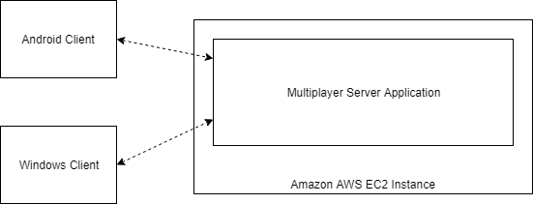

# Design

## Overall Architecture

The project is split into two distinct components, the main game clients which will features two different modes and a multiplayer server which will allow for communication between multiple clients for online games. Both components are going to be written in C# which allows for them to share some code when it comes to the networking communication between them, there will be at least one object that will be the same on both sides.

## Detailed Design

### Game Client

### Server Application

### Network Code

In both applications there will need to be some shared code to allow the networking to function, this was one of the main factors when choosing to use C# for the server programming.



Figure

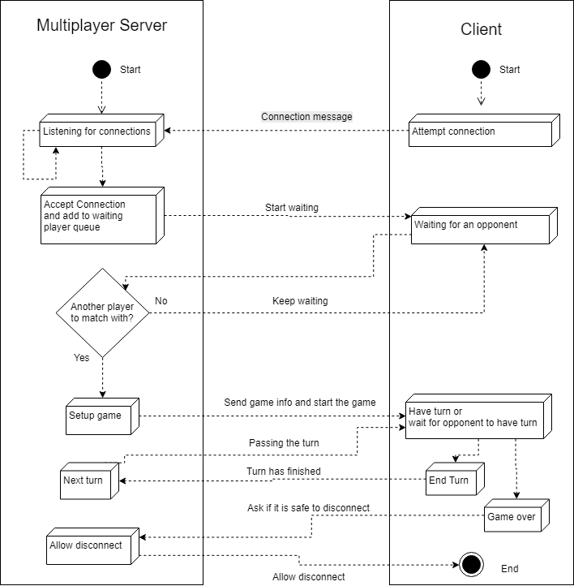

Figure 13

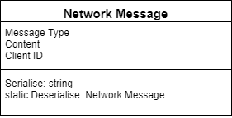

## User Interface Design

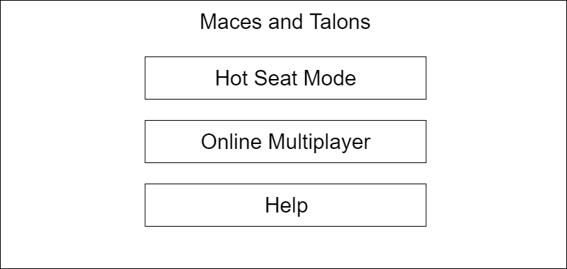

Figure

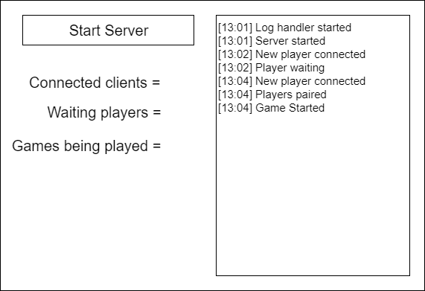

Figure

## Other Relevant Sections

# Implementation

## Game Client

Most of the games client’s implementation followed the design very well, there was some user interface changes once testing had been done and better ways were found to create it. When selecting a team in the offline mode this was originally going to be drop down boxes where the two users would select which side they were on, this felt unnecessary and for only two selections was inconvenient. It was therefore changed to be a set of buttons that toggle the other players team when one person selects a team, this kept the two teams opposite and no problems with both people selecting the same team was possible.

### Game generation

In both the offline mode and multiplayer mode there is quite a lot of code that is reused, the offline code was implemented first but with the aspect that it could be used later for online. Everything is separated into classes, which allowed for easy modification and creation of child classes when making the online multiplayer code.

Originally at the beginning of the design phase there was the possibility of including more than one size of board, because Hnefatafl can be played on a 11x11 or 13x13 board. This meant that an algorithm was designed to allow a board of nth width to be generated if n is odd, Figure 15 shows code that was used to make sure that n was odd.

if (size % 2 != 0)

{

width = size;

height = size;

}

else

{

Debug.Log("Error that size is not an odd number");

}

Figure

To go with the board generation, pieces are generated into their position as well, this is where the limitation of board size was introduced. The 11x11 board was created first and the pieces are setup specifically for that board type, to create the board a class was implemented that creates the physical tiles. A reference is kept in the main game class so that when pieces move to a new tile it can be checked to see if it is a corner or throne tile. When the board size was going to be variable this would have allowed for checking to still work because the corners would move, a rigid coordinate system wouldn’t have made this work.

### Taking pieces

A large technical part of the code was detecting when pieces had been taken by the other team, the location of pieces are stored in a two-dimensional array that represents the game board. From this the game can detect where a piece is in relation to other pieces, the array stores the pieces as a tuple

## Multiplayer Server

## Network Code

### Asynchronous Connection

### Network Message

Saved time by implementing async though code off internet

## Server Hosting

When testing the server application that had been developed

Having to recreate server as console application

# Testing

## Overall Approach to Testing

## Automated Testing

### Unit Tests

### User Interface Testing

### Stress Testing

### Other Types of Testing

## Integration Testing

## User Testing

# Critical Evaluation

## Research

More research into online hosting

## Requirements

Met well except for sounds

## Design Decisions

2D could have been a good idea

## Tools 151

The success of the tools chosen for the project vary, using the Unity engine was the right choice allowing for more time developing the game instead of my own engine to make the game. It provided a good set of tools for developing 3D models and lighting, the user interface was easy to implement using a drag and drop system although tricky to get the scaling working for multiple resolutions.

Using C# for the server may not have been the best decision, unfortunately little thought was given to a practical solution for testing the server at the beginning of the project and Java may have been an easier option due to its compatibility with lots of platforms. A solution was worked out using the original C# project but it did have to be converted into a slightly different application as imagined getting it to work on the Amazon AWS Linux server.

## Future Work

### Authoritative Server

### Google Play integration

### Online Lobby

### 2D View

# Appendices

* 1. Third-Party Code and Libraries

**MK Glow Unity Asset *Free** – This asset provides some fancy glowing materials which I am using for selected pieces in the game. [1]

* 1. Ethics Submission
  2. Code Samples

# Annotated Bibliography

[1] MK Glow Free –

<https://assetstore.unity.com/packages/vfx/shaders/fullscreen-camera-effects/mk-glow-free-28044>

This Unity asset provides some fancy glowing materials.

[2] Hnefatafl (Philippe Schober) (Google Play Store) –

<https://play.google.com/store/apps/details?id=com.fellhuhn.hnefatafl>

[3] Tafl (Jocly) (Google Play Store) –

<https://play.google.com/store/apps/details?id=com.jocly.android.app10_vc_as>

[4] Hnefatafl (MeatballsTeam) (Google Play Store) –

<https://play.google.com/store/apps/details?id=com.meatballsteam.hnefatafl>

[5] Hnefatafl The Viking Game –

<http://www.gamecabinet.com/history/Hnef.html>

[6] Hnefatafl –

<https://boardgamegeek.com/boardgame/2932/hnefatafl>

[7] The History of Hnefatafl –

<http://tafl.cyningstan.com/page/3/the-history-of-hnefatafl>

[8] Android Studio –

<https://developer.android.com/studio/>

An IDE and visual editor for Android applications, a possible candidate for developing the project.

[9] CLI – Common Language Interface –

<https://www.c-sharpcorner.com/UploadFile/f64127/C-Sharp-tutorial-part-2-cli-clr/>

A specification that C# was built upon that describes the way it can run and the environments it can run in.

[10] TCP vs UDP –

<https://www.diffen.com/difference/TCP_vs_UDP>

[11] UDP vs TCP – Gaffer on games - <https://gafferongames.com/post/udp_vs_tcp/>

[12] Real-Time Data Transfer –

<https://www.lifesize.com/en/video-conferencing-blog/tcp-vs-udp>